??

NO

Miss

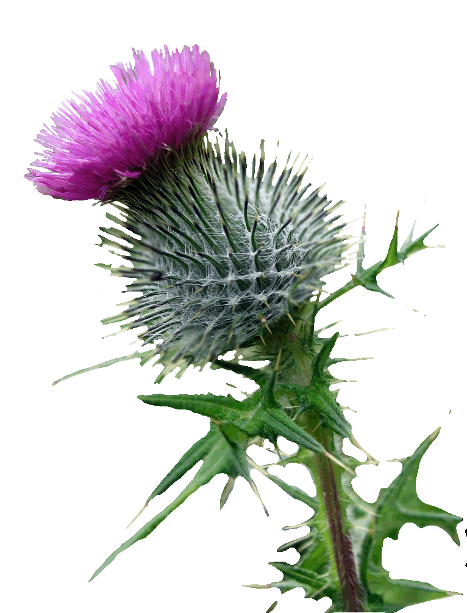

**THISTLE CALEDONIAN SOCIETY   
DECEMBER DAY***(Conducted under the Rules of the Piping & Dancing Assn. Of New Zealand)*

**Saturday 09th December 2023  
Palmerston North**

**Commencing at 9:00 am**

**Venue: Terrace End School Hall,**

**Ruahine St, Palmerston North**

**Adjudicators:**

**Miss Britney Moore - Christchurch**

**Mrs Julie Hawke - Christchurch**

**Entries close: Saturday 02nd December 2023 at 5 p.m.**

**NO LATE ENTRIES ACCEPTED AFTER THIS DATE & TIME**

**ALL EVENTS INCLUDING REELS WILL BE PRE DRAWN**

**Post Entries to: The Competition Secretary  
 32 Keith Street  
 Roslyn**

**Palmerston North, 4414**

**Or email:** [**thistlecaledonian@rocketmail.com**](mailto:thistlecaledonian@rocketmail.com)

**There will be no kitchen operating on this day**

***CONDITIONS OF ENTRY***

* *Conducted under the rules of the Piping & Dancing Association of NZ and the Thistle Caledonian Society Inc.*
* *Dress must be as per Piping & Dancing Association of NZ Rules.*
* ***ALL competitors MUST:***
  + ***be registered with the Piping & Dancing Association***
  + ***provide registration numbers with entries***
  + ***produce current registration cards when collecting numbers***
* *All competitors compete at their own risk and Thistle Caledonian Society Inc. accepts no responsibility for accidents   
  or mishaps, and on these conditions only are entries accepted.*
* *Refund of entry money will be at the discretion of the Committee upon written application to the   
  Thistle Caledonian Society, 32 Keith St, Palmerston North, such application to be received within 7 days of the  
   competition date. A medical certificate for illness or accident should accompany the application.*
* *The fourth place will be awarded when there are 15 or more competitors in each class. A fifth place will be awarded when there are 20 or more competitors in each class.*
* *In the event there are less than five competitors for a championship event, the Committee reserves the right to hold the event   
  as an ordinary dance, and reduce the Prize Money accordingly*
* *Merit Awards and Championship events do not count towards most points prizes.*
* *All cups remain the property of Thistle Caledonian Society Inc. and only professional engraving is acceptable on such cups.   
  PLEASE return cups in a clean and polished manner.*
* *Entry Fee inclusive of music fee.*
* *In the instance where a competitor has events on more than one board at the same time, please notify the officials   
  on* ***BOTH*** *Boards.*
* *In the event of a tie, Rule 13 applies, aggregate marks will not be used*
* *Entries close on* ***Saturday 02nd December 2023, at 5 p.m NO LATE ENTRIES AFTER THIS DATE & TIME WILL BE ACCEPTED***
* *If you elect not to grant the Association/Society the right to use your image, it is your responsibility to remove yourself from situations where photos are likely to be taken, such as at presentation time. The Association does not guarantee that your image will not be published as part of a larger group or performance photograph, and by participating in the competition or event you automatically waive your rights in respect of such image*

**EVENTS....**

|  |  |  |  |  |
| --- | --- | --- | --- | --- |
|  | **NORTH ISLAND CHAMPIONSHIPS** |  |  | **Under 14 Years** |
| 1 | Under 16 Reel O Tulloch |  | 30 | Sword Dance |
| 2 | Under 18 Sword Dance |  | 31 | Highland Fling |
|  |  |  | 32 | Irish Jig (12 & under 14 years) |
|  | **WELLINGTON CENTRE CHAMPIONSHIPS** |  | 33 | Sailors Hornpipe |
| 3 | Under 16 Irish Reel |  |  |  |
| 4 | Under 16 Highland Reel |  |  | **Under 16 Years** |
| 5 | Under 12 Sailors Hornpipe |  | 34 | Highland Fling |
| 6 | Under 12 Highland Fling |  | 35 | Seann Triubhas (14 & under 16) |
| 7 | Under 12 Seann Triubhas |  | 36 | Irish Hornpipe |
| 8 | Under 10 Sword Dance |  | 37 | Sailors Hornpipe |
|  |  |  |  |  |
|  | **MERIT AWARDS** |  |  |  |
| 9 | Under 9 Sword Dance |  |  | **Open** |
| 10 | Under 11 Irish Jig |  | 38 | Highland Fling |
| 11 | Under 13 Highland Fling |  | 39 | Seann Triubhas |
| 12 | Under 14 Irish Hornpipe |  | 40 | Irish Jig S/T |
| 13 | Under 14 Seann Triubhas |  | 41 | Irish Jig D/T |
| 14 | Under 14 Highland Reel (sub Fling) |  |  |  |
|  | **NOVICE** |  |  | **RESTRICTED EVENTS** |
| 15 | Highland Fling Under 14 (4 steps) |  |  | *Restricted to those who have not won more than* |
|  | ***2 competitors or demonstration event only*** |  |  | *three points prizes in the preceding 12 months* |
|  |  |  |  | *including Restricted prizes* |
|  | **6 years and Under** |  |  | **RESTRICTED UNDER 9 YEARS** |
| 16 | Highland Fling (4 steps) |  | 42 | Highland Fling |
| 17 | Irish Jig |  | 43 | Sword Dance |
|  |  |  | 44 | Irish Jig |
|  | **Under 8 Years** |  |  |  |
| 18 | Highland Fling (4 steps) |  |  | **RESTRICTED UNDER 11 YEARS**  Highland Fling  Irish Jig  Sailors Hornpipe |
| 19 | Sword Dance |  | 45 |
| 20 | Irish Jig |  | 46 |
| 21 | Sailors Hornpipe |  | 47 |
|  |  |  |  |  |
|  | **Under 10 Years** |  |  | **RESTRICTED UNDER 14 YEARS** |
| 22 | Highland Fling |  | 48 | Sword Dance |
| 23 | Sword Dance |  | 49 | Highland Fling |
| 24 | Irish Jig (8 & under 10 years) |  | 50 | Irish Jig |
| 25 | Sailors Hornpipe |  |  |  |
|  |  |  |  |  |
|  | **Under 12 Years** |  |  |  |
| 26 | Highland Fling |  |  | **LOCAL COMPETITORS ONLY** |
| 27 | Sword Dance |  | 51 | Under 10 Highland Fling |
| 28 | Irish Jig |  | 52 | 10 & Under 14 Highland Fling |
| 29 | Sailors Hornpipe (10 & Under 12 years) |  | 53 | 14 & Over Highland Fling |
|  |  |  |  |  |
|  |  |  |  | (Local: dancer residing within 60kms of  Palmerston North) |
|  |  |  |  |  |
|  |  |  |  |  |

**ENTRY FEES:** *(Inclusive of Pipers Fees)*

North Island Championship Event $6.00 per Event  
Wellington Centre Championship Events $5.00 per Event  
Novice to Under 14 Years Events $4.00 per Event

Under 16 Years & Open Events $4.50 per Event  
Merit Award Events $4.50 per Event

Restricted Events $4.00 per Event

Local Competitor Events $4.00 per Event

**PRIZES:**

North Island Championship Events 1 & 2 **1st** Sash, Certificate & $20.00, **2nd** $15.00, **3rd** $10.00

Wellington Centre Championship Events 3 - 6 **1st** Sash & $10.00, **2nd Sash &** $8.00, **3rd  Sash &** $6.00

Novice to Under 14 Years Events Medals **1st, 2nd 3rd**

Under 16 Years & Open Events **1st** $8.00, **2nd** $6.00, **3rd** $5.00

Merit Award Events 1st**st Sash, 2nd Sash, 3rd Sash**

Restricted Events Medals **1st, 2nd 3rd**

Local Competitor Events Rosettes 1st, 2nd, 3rd

**TROPHIES / CUPS**

|  |  |  |  |
| --- | --- | --- | --- |
|  |  | **Trophy / Cup** | |
| **Novice** |  | *Couchman Cup* | |
| **6 & Under** |  | *Suzanne Dunstal Cup – Most Points M & J McDonald Cup – Runner up* | |
| **Under 8 Years** |  | *Ashley Mitchell Cup – Most points Christine Morris Cup – Runner up* | |
| **Under 10 Years** |  | *Leslie Mitchell Cup – Most Points Manawatu OPD Cup – Runner up* | |
| **Under 12 Years** |  | *McMillan Cup – Most Points George Roberston Cup – Runner up* | |
| **Under 14 Years** |  | *BJ Holden Cup – Most Points Cotton Challenge Cup – Runner up* | |
| **Under 16 Years** |  | *Irene Boulton Cup – Most Points Graeme Bilsland Cup – Runner up* | |
|  |  |  | |
| **Open** |  | *Haig Challenge Cup – Most Points Claemohr Ltd Tray – Runner up* | |
| **Restricted Under 9 Years** |  | *Couchman Challenge Tray – Most Points* | |
| **Restricted Under 11 Years** |  | *Weggery Challenge Cup – Most Points* | |
| **Restricted Under 14 Years** |  | *Square Day Challenge Cup – Most Points* | |
| **OTHER CUPS FOR PRESENTATION:** | | | |
| **Under 8 Years** |  | *Pretty Family Cup – Local Competitor Most Points Highland Only* | |
| **Under 10 Years** |  | *Allen Challenge Cup – Local Competitor Most Points Highland Only* | |
| **Under 12 Years** |  | *TCS Challenge Cup – Local Competitor Most Points Highland Only* | |
| **Under 14 Years** |  | *Pretty Challenge Cup – Local Competitor Most Points Highland Only* | |
| **Under 16 Years** |  | *Claridge Family Cup – Local Competitor Most Points Highland Only* | |
| **Open** |  | *H Warrington Tray – Local Competitor Most Points Highland Only* | |
| WCC Under 16 Championships |  | *Adeline Hobbs Cup - Most points over WCC Reel O Tulloch, Irish Reel & Highland Reel* | |
| Chiefs Cup |  | *Local competitor awarded for perservance over previous 12 months* | |
| **Doug McDowell Cup** |  | *Most Points 14 and over – Own Age Group* | |
| **Peter Sheridan Cup** |  | *Most improved Local Competitor Irish Dancer U12* | |
| **Allen Challenge Award** |  | *Adjudicators to award – For the competitor demonstrating best musical appreciation in all classes.* | |
| **Grant Wishnowsky Cup** |  | *Most Points Highland Under 12* | |
| **Norma Sievert Memorial Trophy** |  | *Best dressed Highlander – Open to all Local competitors, to be awarded by the adjudicators.* | |
|  | | |  |
| **LOCAL COMPETITORS ONLY HIGHLAND FLING:** | | |  |
| **Under 10 Highland Fling** |  | *Raewyn Lockett Cup* |  |
| **10 and Under 14 Highland Fling** |  | *Keltie Smith Cup* |  |
| **14 and Over Highland Fling** |  | *A W Short Memorial Cup* |  |



**ENTRY FORM – Thistle Caledonian Society Inc.  
HIGHLAND SQUARE DAY – 09TH December 2023 - Commencing 9:00am,**

Name: Registration No.

Address: Date of Birth:   
 Phone Number:

Email Address: Dance Teacher:

|  |  |  |  |  |  |  |  |
| --- | --- | --- | --- | --- | --- | --- | --- |
| **Event** |  | **Tick** | **Fee** | **Event** |  | **Tick** | **Fee** |
|  | **NORTH ISLAND CHAMPIONSHIPS** |  |  |  | **UNDER 14 YEARS** |  |  |
| 1 | Under 16 Reel O Tulloch |  | 6.00 | 30 | Sword Dance |  | 4.00 |
| 2 | Under 18 Sword Dance |  | 6.00 | 31 | Highland Fling |  | 4.00 |
|  | **WELLINGTON CENTRE CHAMPIONSHIPS** |  |  | 32 | Irish Jig 12 & under 14 |  | 4.00 |
| 3 | Under 16 Irish Reel |  | 5.00 | 33 | Sailors Hornpipe |  | 4.00 |
| 4 | Under 16 Highland Reel |  | 5.00 |  | **UNDER 16 YEARS** |  |  |
| 5 | Under 12 Sailors Hornpipe |  | 5.00 | 34 | Highland Fling |  | 4.50 |
| 6 | Under 12 Highland Fling |  | 5.00 | 35 | Seann Triubhas 14 & under 16 |  | 4.50 |
| 7 | Under 12 Seann Triubhas |  | 5.00 | 36 | Irish Hornpipe |  | 4.50 |
| 8 | Under 10 Sword Dance |  | 5.00 | 37 | Sailors Hornpipe |  | 4.50 |
| 9 | M/A Under 9 Sword Dance |  | 4.50 |  |  |  |  |
| 10 | M/A Under 11 Irish Jig |  | 4.50 |  |  |  |  |
| 11 | M/A Under 13 Highland Fling |  | 4.50 |  | **OPEN** |  |  |
| 12 | M/A Under 14 Irish Hornpipe |  | 4.50 |  |  |  |  |
| 13 | M/A Under 14 Seann Triubhas |  | 4.50 | 38 | Highland Fling |  | 4.50 |
| 14 | M/A Under 14 Highland Reel |  | 4.50 | 39 | Seann Triubhas |  | 4.50 |
| 15 | NOVICE HIGHLAND FLING |  | 4.00 | 40 | Irish Jig S/T |  | 4.50 |
|  | **6 & UNDER** |  |  | 41 | Irish Jig D/T |  | 4.50 |
| 16 | Highland Fling |  | 4.00 |  |  |  |  |
| **17** | **Irish Jig** |  | 4.00 |  |  |  |  |
|  | **UNDER 8 YEARS** |  |  |  | **RESTRICTED UNDER 9 YEARS** |  |  |
| 18 | Highland Fling |  | 4.00 | 42 | Highland Fling |  | 4.00 |
| 19 | Sword Dance |  | 4.00 | 43 | Sword Dance |  | 4.00 |
| 20 | Irish Jig |  | 4.00 | 44 | Irish Jig |  | 4.00 |
| 21 | Sailors Hornpipe |  | 4.00 |  | **RESTRICTED UNDER 11 YEARS** |  |  |
|  |  |  |  | 45 | Highland Fling |  | 4.00 |
|  | **UNDER 10 YEARS** |  |  | 46 | Irish Jig |  | 4.00 |
| 22 | Highland Fling |  | 4.00 | 47 | Sailors Hornpipe |  | 4.00 |
| 23 | Sword Dance |  | 4.00 |  |  |  |  |
| 24 | Irish Jig (8 & under 10) |  | 4.00 |  | **RESTRICTED UNDER 14 YEARS** |  |  |
| 25 | Sailors Hornpipe |  | 4.00 | 48 | Sword Dance |  |  |
|  |  |  |  | 49 | Highland Fling |  | 4.00 |
|  | **UNDER 12 YEARS** |  |  | 50 | Irish Jig |  | 4.00 |
| 26 | Highland Fling |  | 4.00 |  | **LOCAL COMPETITORS ONLY** |  |  |
| 27 | Sword Dance |  | 4.00 | 51 | Under 10 Highland Fling |  | 4.00 |
| 28 | Irish Jig |  | 4.00 | 52 | 10 and Under 14 Highland Fling |  | 4.00 |
| 29 | Sailors Hornpipe (10 & under 12) |  | 4.00 | 53 | 14 and Over Highland Fling |  | 4.00 |
|  | **NO LATE ENTRIES ACCEPTED** |  |  |  | **TOTAL DANCING FEES** | $ | |
| ***Entries Close Saturday 02 December at 5 p.m.*** | | | |  | ADMIN FEE (per family) | $ 5.00 | |
|  | | | |  | **TOTAL AMOUNT ENCLOSED** |  |  |

Entries to Bank account **03-0726-0483523-00** and post your entry form to

https://encrypted-tbn2.gstatic.com/images?q=tbn:ANd9GcQs2ZgUHLsc3SZbkN_P8qZvHUYUx8TPCOza7fjpaPjzs5ucRN_KYw32 Keith Street, Palmerston North, 4414, or email to: [thistlecaledonian@rocketmail.com](mailto:thistlecaledonian@rocketmail.com), Please include competitors ‘Name’ in the reference details.  
For any enquires please email the competition secretary: [thistlecaledonian@rocketmail.com](mailto:thistlecaledonian@rocketmail.com)

I hereby grant the Piping & Dancing Assn NZ Inc the right to use my name and image (photography or video) in any media publication, website or Association publication (Please also refer to Conditions of Entry) YES / NO