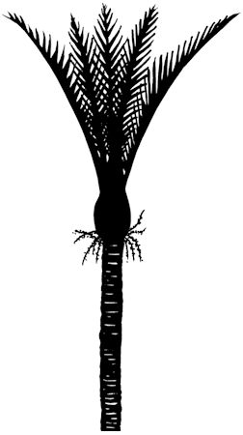
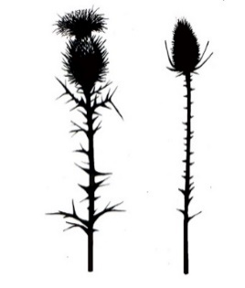
Hokitika Highland Dancing Competitions

Saturday 18 July 2026
St Mary’s School Hall, 87 Sewell Street, Hokitika
Commencing 9:30am

PERMIT APPROVED 24/4/26 BY DANITTA FINDLAY

Adjudicator: Mrs Heather-Maree Allen (Christchurch)

Trophy List
Hampton Sisters Cup Most Points Under 8
Phoebe Todd Challenge Cup Most Points Under 10
Indie Craw Trophy (1) Most Points Under 12
Campbell Cup Most Points Under 14
Westland A&P Association Cup Runner Up Under 14
Parsons Family Cup Most Points Open
Caledonian Cup Runner Up Open
Thistle & Fern Challenge Cup Most Points Restricted Under 14
Gordon Clan Cup Novice Highland Fling Under 14
Shamrock Cup Single Time Irish Jig Local Open
Indie Craw Trophy (2) Most Points Overall
Tuuta Family Cup Most Promising Dancer Under 14

Entry form
Please use the electronic entry form at the link below. If you require an alternate version or have any queries, please contact greymouthhighlanddancing@gmail.com

https://www.cognitoforms.com/WestCoastHighlandDancing/HokitikaHighlandDancingCompetition2026

Novice: for competitors who have not won a first prize in any dance
Restricted: for competitors who have not won more than three first places in the dance stated
Local: defined as resident in either the Buller, Grey or Westland districts

Entry Fees: $4.00 per dance under 14 years (excluding Novice Highland Fling class 1 and Merit Award classes 4, 8, 10, 16, 22)
$5.00 per Novice Highland Fling (class 1), Merit award (classes 4, 8, 10, 16, 22), and Open (classes 19, 20, 21, 22, 23, 24)
$10.00 Administration Fee per family
Music fee is included in entry fee
Late entries = double fees. No refunds available after closing date of entries.

Entries Close: 28 June 2026
Please use the electronic entry form
https://www.cognitoforms.com/WestCoastHighlandDancing/HokitikaHighlandDancingCompetition2026

Programme: A programme will be emailed to all competitors following the closing of entries. Competitors dancing order will be randomly drawn and published in the programme, but this is subject to change at the committees’ discretion.

Rules and Conditions

- All events conducted under the NZ Piping & Dancing Association rules
- All entries must be accompanied by correct payment
- Dancers compete at their own risk
- Current NZ P&D registration must be shown when uplifting number
- Prizes as follows:
  - All classes under 14 (excluding class 1, 4, 8, 10, 16) = 1st, 2nd and 3rd ribbons
  - Open classes (excluding class 22) = 1st $10, 2nd $7, 3rd $5
  - Merit Award and Novice Highland Fling (classes 1, 4, 8, 10, 16, 22) = rosettes for 1st, 2nd, 3rd
  - VHC, HC and C certificates will be awarded at the discretion of the adjudicator
  - In the case of more than 15 competitors in any class a 4th place ribbon will be awarded.
- In Reel classes where there are insufficient entries a solo dance will be substituted
- Double sword entry (class 30) is payable by both competitors, partners name must be stated on entry form
- Where Most Points or Runner Up for more than one class is awarded, this will be scored as per Method A (see PDANZ bylaw 13)

Piping and Dancing Association of New Zealand (Inc) Disclaimer
“By entering this competition or event, I agree to hereby grant the Piping and Dancing Association of New Zealand (Association) the right to use my name, image, photograph, picture or video captured performance in connection with the Association. This includes granting the Association all rights to reproduce, edit, exhibit or otherwise exploit my name, image, photograph, picture or video captured performance, in whole or in part, in any media publication, Association website or materials or other Association publication”

“If you elect not to grant the Association the right to use your image, it is your responsibility to remove yourself from situations where photos are likely to be taken, such as at presentation time. The Association does not guarantee that your image will not be published as part of a larger group or performance photograph, and by participating in the competition you automatically waive your rights in respect of such images”.

List of Competition Events

- Novice Highland Fling Under 14
- Single Time Irish Jig Local Open
- Highland Fling Under 8
- Sword Dance Under 8*
- Single Time Irish Jig Under 8
- Highland Fling Under 10
- Sword Dance Under 10
- Single Time Irish Jig Under 10*
- Sailors Hornpipe Under 10
- Highland Fling Under 12*
- Sword Dance Under 12
- Single Time Irish Jig Under 12
- Sailors Hornpipe Under 12
- Sword Dance Under 14
- Seann Triubhas Under 14
- Highland Reel Under 14* (sub Highland Fling)
- Single Time Irish Jig Under 14
- Sailors Hornpipe Under 14
- Highland Fling Open
- Seann Triubhas Open
- Reel O’Tulloch Open (sub Sword Dance)
- Irish Hornpipe Open*
- Double Time Irish Jig Open
- Sailors Hornpipe Open
- Highland Fling Restricted Under 14
- Sword Dance Restricted Under 14
- Single Time Irish Jig Restricted Under 14
- Sailors Hornpipe Restricted Under 14
- Double Sword Under 14

*indicates Merit Award class

