**Hokitika Highland Dancing Competitions**

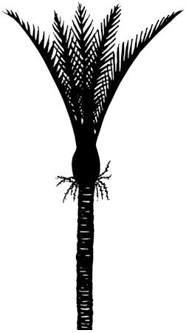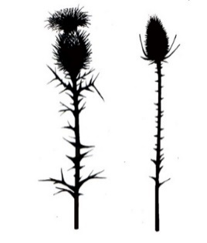

**Saturday 21 June 2025**

**St Mary’s School Hall, 87 Sewell Street, Hokitika**

**Commencing 9:30am**

**Permit issued 2/4/2025 (Cushla Piesse MNZM)**

**Adjudicator: Mrs Yvonne Fenemor (Richmond)**

**Trophy List**

Hampton Sisters Cup Most Points Under 8

Phoebe Todd Challenge Cup Most Points Under 10

Indie Craw Trophy (1) Most Points Under 12

Campbell Cup Most Points Under 14

Westland A&P Association Cup Runner Up Under 14

Parsons Family Cup Most Points Open

Caledonian Cup Runner Up Open

Thistle & Fern Challenge Cup Most Points Restricted Under 14

Gordon Clan Cup Novice Highland Fling Under 14

Shamrock Cup Single Time Irish Jig Local Open

Indie Craw Trophy (2) Most Points Overall

Tuuta Family Cup Most Promising Dancer Under 14

**Entry form**

Please use the electronic entry form at the link below. If you require an alternate version or have any queries, please contact [greymouthhighlanddancing@gmail.com](mailto:greymouthhighlanddancing@gmail.com)

<https://www.cognitoforms.com/WestCoastHighlandDancing/HokitikaHighlandDancingCompetition>

**Novice:** for competitors who have not won a first prize in any dance

**Restricted:** for competitors who have not won more than three first places in the dance stated

**Local:** defined as resident in either the Buller, Grey or Westland districts

**Entry Fees:** $4.00 per dance under 14 years (excluding Matariki Award classes 6, 10, 12, 18, 24)

$5.00 per Matariki award (classes 6, 10, 12, 18, 24) and Open (classes 21, 22, 23, 25, 26)

$10.00 Administration Fee per family

Music fee is included in entry fee

Late entries = double fees. No refunds available after closing date of entries.

**Entries Close:** 7 June 2025

Please use the electronic entry form

<https://www.cognitoforms.com/WestCoastHighlandDancing/HokitikaHighlandDancingCompetition>

**Programme:** A programme will be emailed to all competitors following the closing of entries. Competitors dancing order will be randomly drawn and published in the programme, but this is subject to change at the committees’ discretion.

**Rules and Conditions**

1. All events conducted under the NZ Piping & Dancing Association rules
2. All entries must be accompanied by correct payment
3. Dancers compete at their own risk
4. Current NZ P&D registration must be shown when uplifting number
5. Prizes as follows:
   1. All classes under 14 (excluding class 1) = 1st, 2nd and 3rd ribbons
   2. Open classes (excluding class 24) = 1st $10, 2nd $7, 3rd $5
   3. Matariki Award and Novice Highland Fling (classes 1, 6, 10, 12, 18, 24) = rosettes for 1st, 2nd, 3rd
   4. VHC, HC and C certificates will be awarded at the discretion of the adjudicator
   5. In the case of more than 15 competitors in any class a 4th place ribbon will be awarded.
6. In Reel classes where there are insufficient entries a solo dance will be substituted
7. Double sword entry (class 30) is payable by both competitors, partners name must be stated on entry form

**Piping and Dancing Association of New Zealand (Inc) Disclaimer**

“By entering this competition or event, I agree to hereby grant the Piping and Dancing Association of New Zealand (Association) the right to use my name, image, photograph, picture or video captured performance in connection with the Association. This includes granting the Association all rights to reproduce, edit, exhibit or otherwise exploit my name, image, photograph, picture or video captured performance, in whole or in part, in any media publication, Association website or materials or other Association publication”

“If you elect not to grant the Association the right to use your image, it is your responsibility to remove yourself from situations where photos are likely to be taken, such as at presentation time. The Association does not guarantee that your image will not be published as part of a larger group or performance photograph, and by participating in the competition you automatically waive your rights in respect of such images”.