**saturday 15 November 2025**

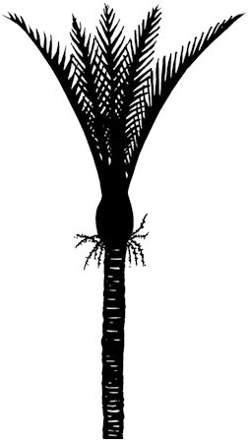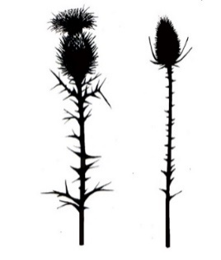

**Grey Main School Hall, 12 Joyce Crescent, Greymouth**

**Commencing 9:30am**

**Adjudicator: Mrs Denise Matheson (Nelson)**

**Trophy List**

|  |
| --- |
| Loma Charteris Challenge Shield, Most Points Classes 3-5 |
| Hazel Robertson Challenge Cup, Runner up Classes 3-5 |
| Mary Hines Challenge Cup, Irish Jig U8 |
| Vivienne Smith Challenge Cup, Most Points Classes 6-9 |
| Sandy Robb Challenge Cup, Runner Up Classes 6-9 |
| F L Bell Challenge Cup, Sailors Hornpipe U10 |
| Robb Memorial Challenge Cup, Most Points Classes 10-13 |
| Elizabeth Robb Challenge Cup, Runner Up Classes 10-13 |
| Jewel Hawker Challenge Cup, Irish Jig U12 |
| Greymouth Highland Pipe Band Challenge Cup, Most Points Classes 14-18 |
| Len Goodall Challenge Cup, Runner Up Classes 14-18 |
| Scottish Society Challenge Cup, Seann Truibhas U14 |
| Colleen Stevenson Challenge Cup, Sailors Hornpipe U14 |
| Alison Paton Senior Challenge Cup, Most Points Classes 19-24 |
| Aileen Hill Challenge Cup, Runner Up Classes 19-24 |
| Chamberlain Cup, Highland Fling Open |
| T G Campbell Challenge Cup, ST Jig Open |
| Buchanan Challenge Cup, Most Points Classes 25-28 |
| Sullivan Trophy, Runner Up Classes 25-28 |
| Delwyn Bishell Challenge Trophy, Restricted Sword U14 |
| David Hadley Junior Challenge Cup, Novice Fling U14 |
| Greymouth Competition Society Challenge Cup, Highland Fling Local Open |
| Johnstone Clan Cup, Double Sword Under 14 |
| Greymouth Competition Society Cup, Most Promising Dancer U14 |

**Scholarship**

We have received an anonymous donation of $100 towards tuition fees. As per the donor, this is to be awarded to the Most Promising Dancer Under 14 (selected by adjudicator).

**Entry form**

Please use the electronic entry form at the link below. If you require an alternate version or have any queries, please contact [greymouthhighlanddancing@gmail.com](mailto:greymouthhighlanddancing@gmail.com)

<https://www.cognitoforms.com/WestCoastHighlandDancing/GreymouthHighlandDancingCompetition>

PERMIT ISSUED BY D FINDLAY 1/9/2025

**Novice:** for competitors who have not won a first prize in any dance

**Restricted:** for competitors who have not won more than three first places in the dance stated

**Local:** defined as resident in either the Buller, Grey or Westland districts

**Entry Fees:** $4.00 per dance under 14 years (excluding Merit Award classes 3, 8, 12, 16, 22)

$5.00 per Merit award (classes 3, 8, 12, 16, 22) and Open (classes 19, 20, 21, 22, 23, 24)

$10.00 Administration Fee per family

Music fee is included in entry fee

Late entries = double fees. No refunds available after closing date of entries.

**Entries Close:** 1 November 2025

Please use the electronic entry form

<https://www.cognitoforms.com/WestCoastHighlandDancing/GreymouthHighlandDancingCompetition>

**Programme:** A programme will be emailed to all competitors following the closing of entries. Competitors dancing order will be randomly drawn and published in the programme, but this is subject to change at the committees’ discretion.

**Rules and Conditions**

1. All events conducted under the NZ Piping & Dancing Association rules
2. All entries must be accompanied by correct payment
3. Dancers compete at their own risk
4. Current NZ P&D registration must be shown when uplifting number
5. Prizes as follows:
   1. All classes under 14 (excluding class 1) = 1st, 2nd and 3rd ribbons
   2. Open classes (excluding class 22) = 1st $10, 2nd $7, 3rd $5
   3. Merit Award and Novice Highland Fling (classes 1, 3, 8, 12, 16, 22) = rosettes for 1st, 2nd, 3rd
   4. VHC, HC and C certificates will be awarded at the discretion of the adjudicator
   5. In the case of more than 15 competitors in any class a 4th place ribbon will be awarded.
6. In Reel classes where there are insufficient entries a solo dance will be substituted
7. Double sword entry (class 29) is payable by both competitors, partners name must be stated on entry form
8. Where Most Points or Runner Up for more than one class is awarded, this will be scored as per Method A (see PDANZ bylaw 13)

**Piping and Dancing Association of New Zealand (Inc) Disclaimer**

“By entering this competition or event, I agree to hereby grant the Piping and Dancing Association of New Zealand (Association) the right to use my name, image, photograph, picture or video captured performance in connection with the Association. This includes granting the Association all rights to reproduce, edit, exhibit or otherwise exploit my name, image, photograph, picture or video captured performance, in whole or in part, in any media publication, Association website or materials or other Association publication”

“If you elect not to grant the Association the right to use your image, it is your responsibility to remove yourself from situations where photos are likely to be taken, such as at presentation time. The Association does not guarantee that your image will not be published as part of a larger group or performance photograph, and by participating in the competition you automatically waive your rights in respect of such images”