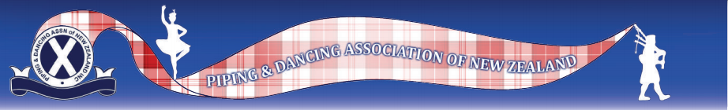

Now that New Zealand is at Covid Level 1 and competitions are restarting, The Piping and Dancing Association has provided the following guidelines to reflect the increased hygiene requirements that should be maintained:

1. Any person who is unwell should not be in attendance at the competition.

2. Organisers should provide appropriate hand washing facilities throughout the day (liquid soap and disposable paper towels), along with hand sanitizer. Suitable rubbish receptacles must be provided.

3. If food is being sold, strict hygiene measures must be observed. Organisers may want to consider using disposable cups, plates.

4. Organisers should be aware of all attendees (not just competitors) to enable contact tracing.

5. Dancing competitors should be allowed to wear face masks if they choose to do so.

6. Organisers should predraw events or have the board steward draw for all competitors.

7. Board stewards should place and remove swords to again reduce a contact point.

