HIGHLAND MASTER CLASSES

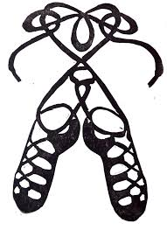

We are excited to offer Highland Master Classes with our adjudicator, Christine Paul , on Thursday 4 October, the day following the MPACS Highland competition.

- VENUE : Central Rugby Clubrooms, Lansdowne Road

- TIMETABLE : 9.30 – 10.30am Under 10 years
10.45 – 12.00pm 10 – 14 years
12.15 – 1.30pm 14 years & over

- FEES : Under 10 years $15
10 years & over $20

Numbers will be limited for these classes. Please register for the Master Class on your entry form and include your Master Class fee with your entry fees.

